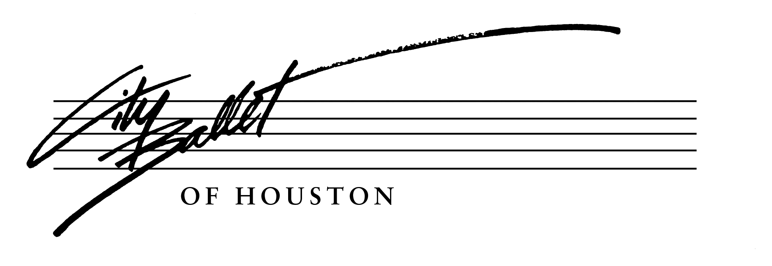
Summer Workshop Registration Form
July 28 – August 3, 2019
Academy of City Ballet of Houston, 1331 Upland Dr. #6, Houston, TX 77043, 346-701-7275
Please ensure you print clearly (especially your email address). We will use email to provide reminders and updates on the Summer Workshop.
Dancer’s Name:
Parent/Guardian’s Name:
Email:
Address:
Phone(s): |  | Male/Female  Circle One | Date of Birth: | Age:
Name of current ballet school and level:
How did you hear about this Summer Workshop?
Terms and Conditions
I hereby request my child’s acceptance to attend City Ballet of Houston’s 2019 Summer Workshop. I understand and am aware my child will be participating in physical activities and the potential for accidents exist. In consideration of acceptance to 2019 Summer Workshop:
- I indemnify and hold harmless City Ballet of Houston, Academy of City Ballet of Houston and/or its staff from any and all liability claims, damage, injury or illness sustained.
- I grant permission for City Ballet of Houston to provide or obtain medical attention for my child in the event of sickness or injury, and I understand accident insurance or medical care is not included in the Workshop costs. Should a dancer require special medical treatment, prescriptions, or hospital care during Workshop, parents/guardian/self shall bear all expenses including transportation.
- I agree City Ballet of Houston may photograph or videotape my child for use in promotional materials.
- We (parent/guardian/dancer) have read the Registration Form and all agree to follow the rules as directed.

Parent/Guardian Signature:
Date:

Payment Information and Insurance
Tuition: $700.00 Deposit: $150.00 (due 7/15/2019)

There is a non-refundable registration fee/deposit deducted from the tuition. Registration is ongoing please mail or scan/email this form with the $150.00 registration fee/deposit to the following address:
Academy of City Ballet of Houston, 1331 Upland Dr. #6, Houston, TX 77043 Balance in full should be paid by 7/1/19.

***If you need to use a credit card, please notify the office. You will need to speak with a representative of City Ballet of Houston, the non-profit, as Academy of City Ballet of Houston cannot take your credit card information or financial information for CBH sponsored activities.

For additional information, please contact info@cityballetofhouston.com, or call 346-701-7275.

